Pending Sale Graph (2019 : 2020)

(Covit-19 으로 3/13 National Emergency 가 발효, 워싱턴주에선 3/26 ‘ Stay Home’ 명령 발효)

이스트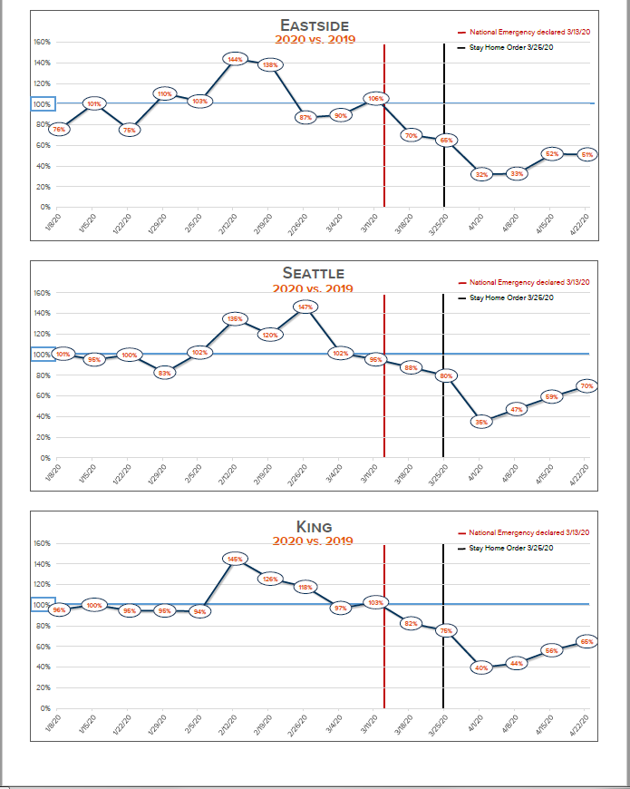 사이드:

32% (4/1) 🡪 51% (4/22)

시애틀:

36% (4/1) 🡪 70% (4/22)

킹카운티:

40% (4/1) 🡪 65% (4/22)  
 < Source: Windermere Real Estate/East>